UI5 Training

HTML elements

Javascript

JQuery

CSS3

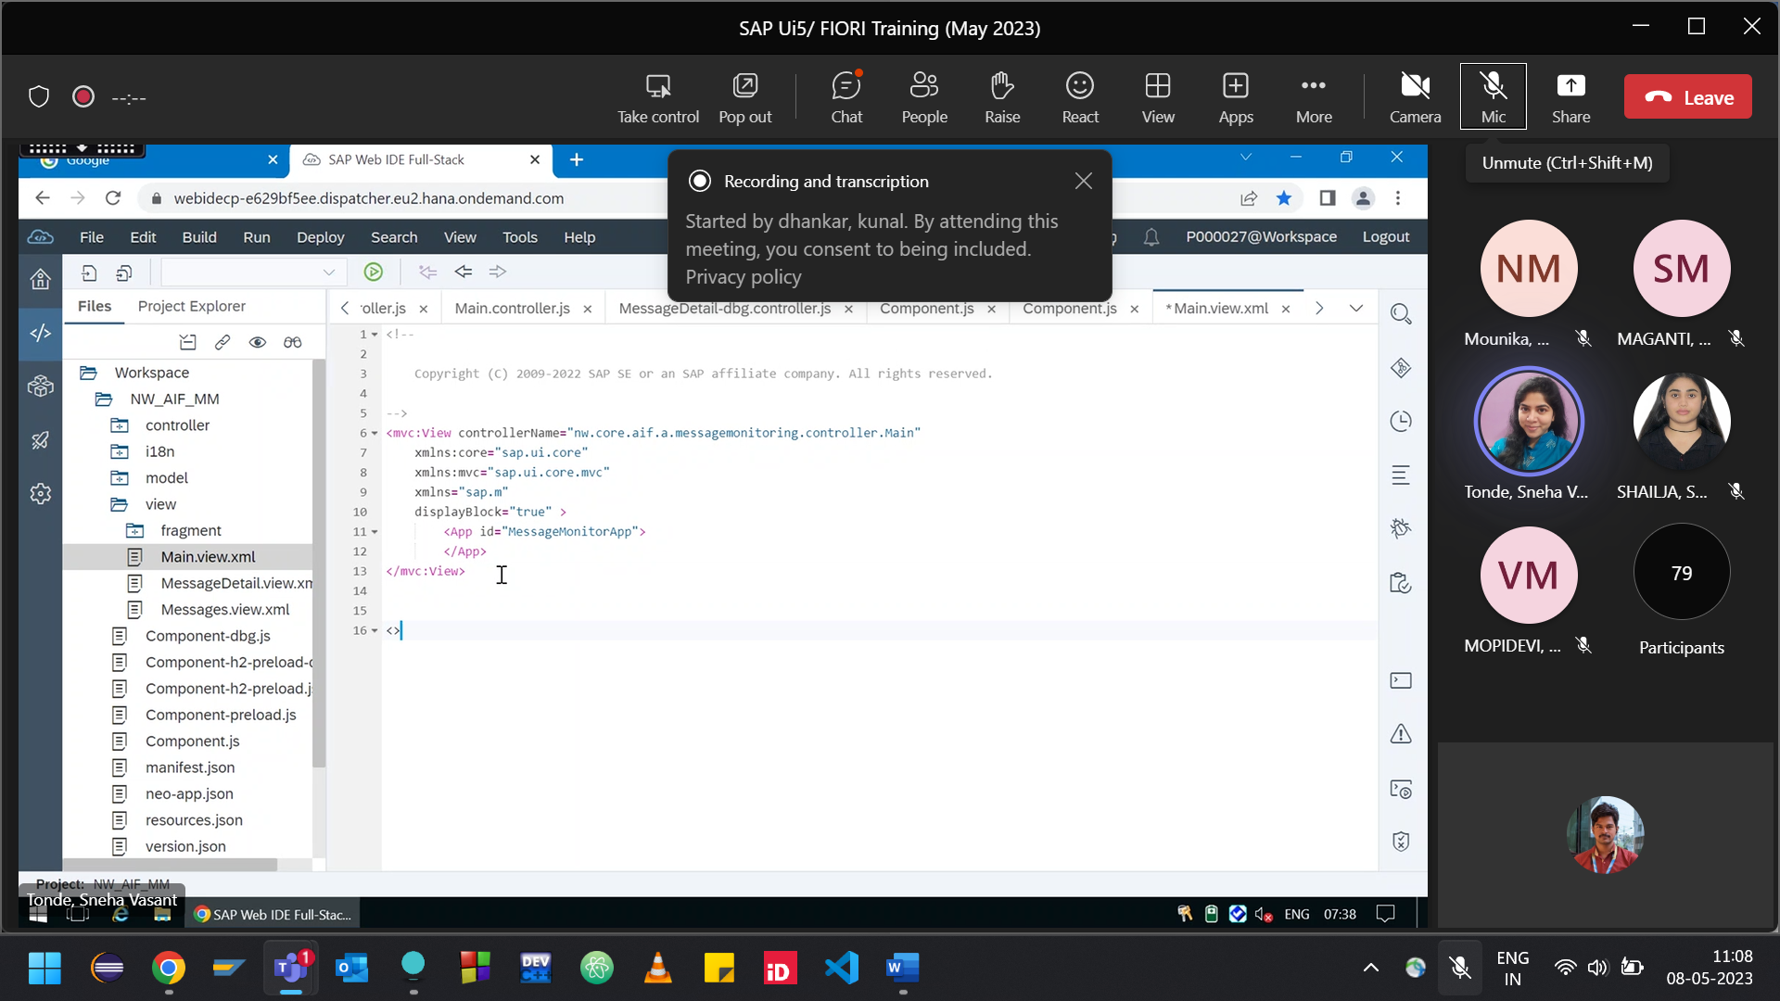

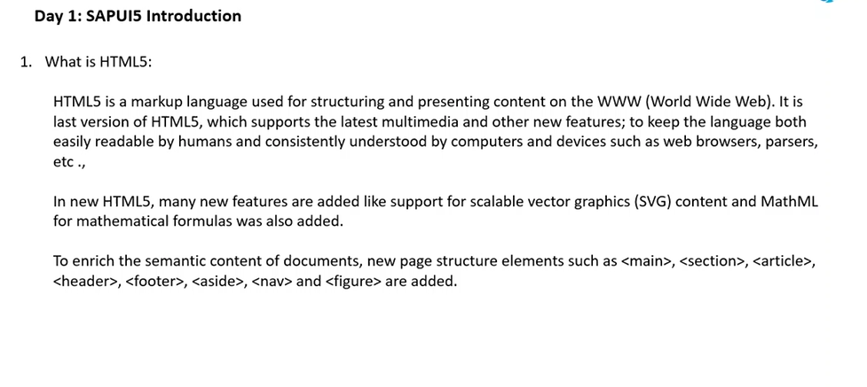

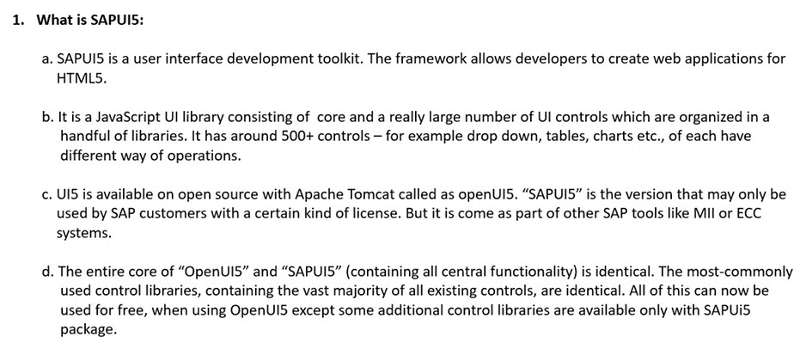

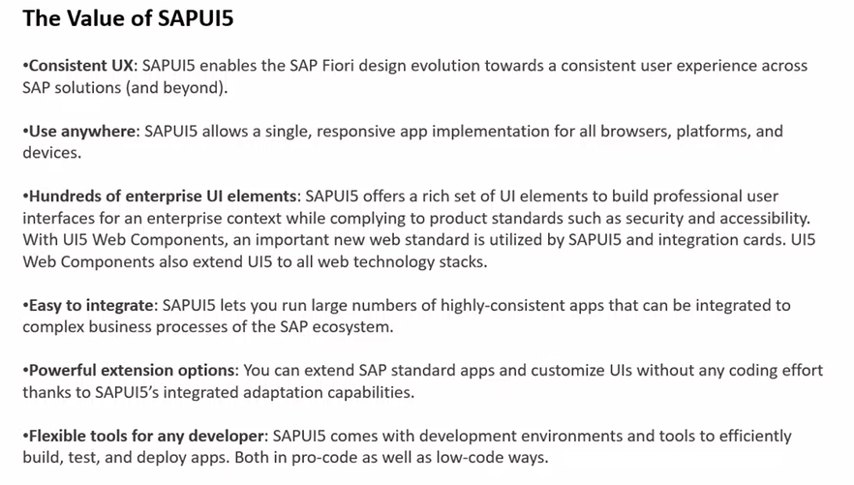

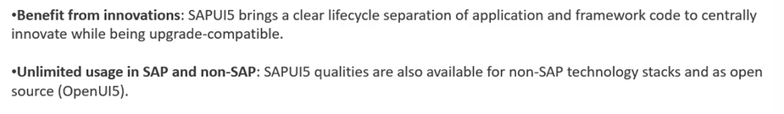

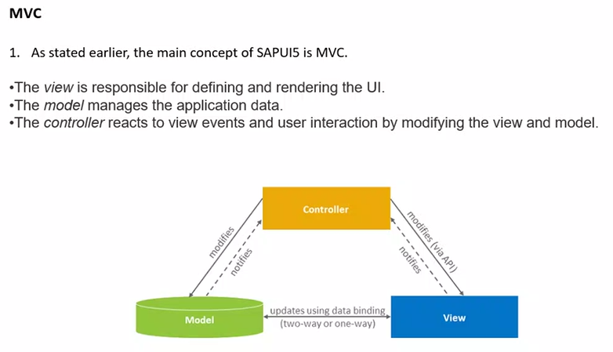

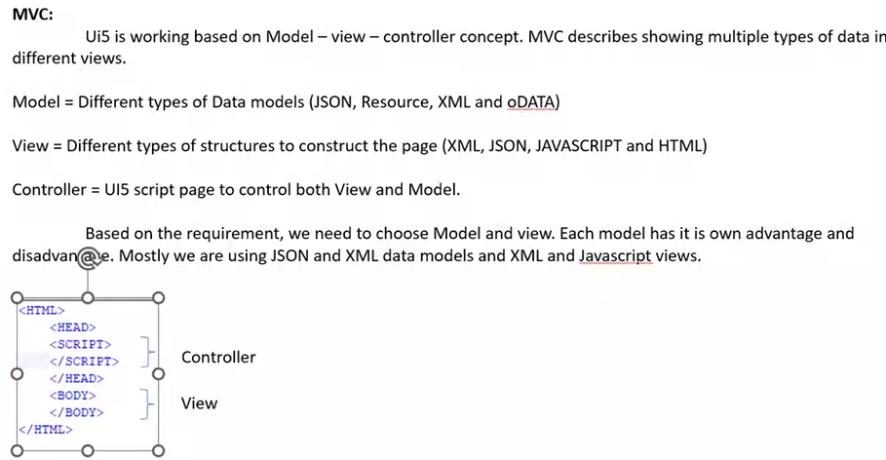

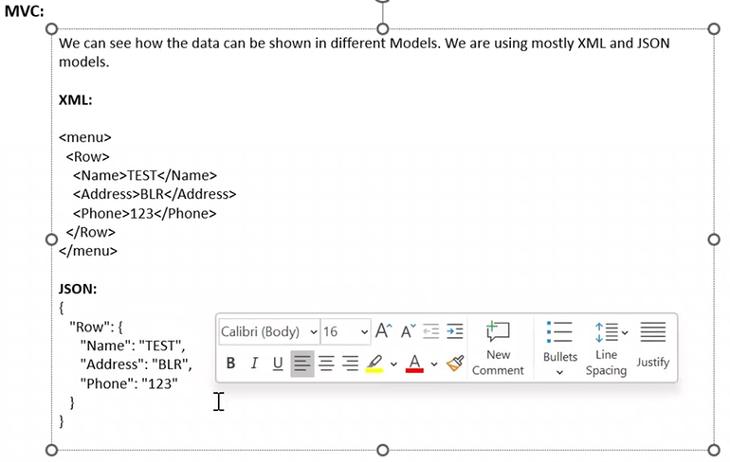

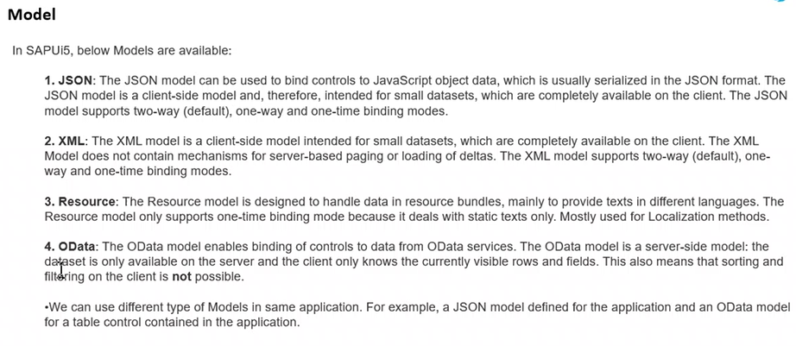

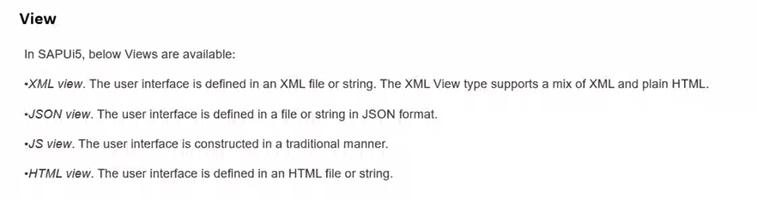

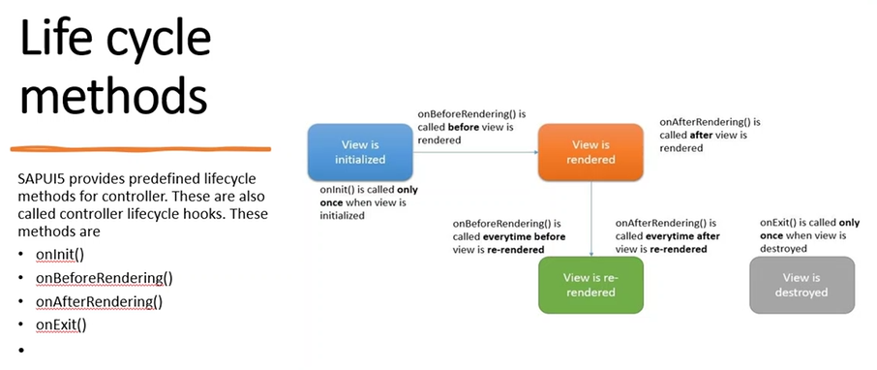

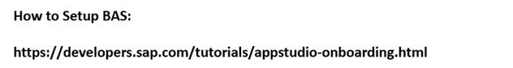

How to Setup BAS:

<https://developers.sap.com/tutorials/appstudio-onboarding.html>

Set Up SAP Business Application Studio for Development | SAP

SAP Business Application Studio is a development environment available on SAP Business Technology Platform. Before you can start developing using SAP Business Application Studio, administrators mus...